Chapter 4
Logan Yeubanks

4.1: When I checked I saw that the number of files I added was accurate.

4.2: Nothing seemed to happen when I tried to remove a file. I expected to get an error because I was calling remove on a empty list.

4.3: After I removed the first file and tried to list it again it showed me what was originally the second file I inputted. In other words, the second file I inputted was moved to index 0.

4.4: private ArrayList<Book> library;

4.5: cs101 = new ArrayList<student>();

4.6: private ArrayList<MusicTrack> tracks;

4.7:
library = new ArrayList<Book>();
library = new ArrayList<>();

cs101 = new ArrayList<student>();
cs101 = new ArrayList<>();

track = new ArrayList<MusicTrack>();
track = new ArrayList<>();

4.8: It returns 10 because that is the number of objects in the list.
4.9: items.get(4);

4.10: 14 would be the last item in a collection of 15 objects because the list starts at 0.

4.11: files.add(favoriteTrack);

4.12: dates.remove(2);

4.13: It would move to 5 after index 0 is removed and then remain at 5 even after index 9 is removed.

4.14:

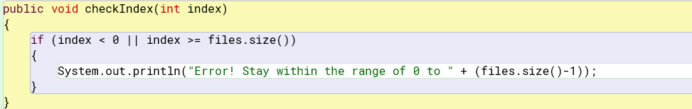

4.15:
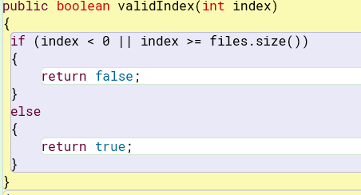

4.16:
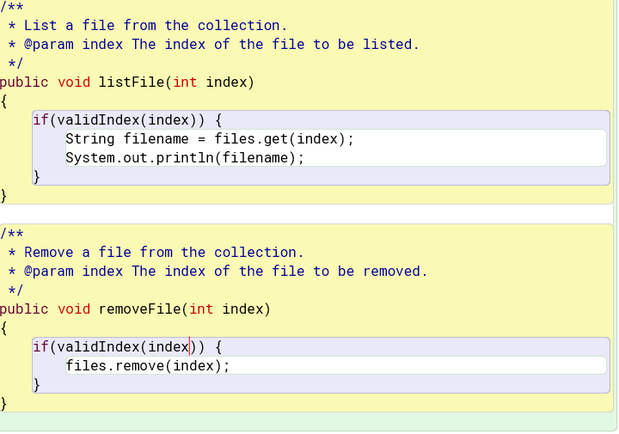

4.17: When a file that does not exist is used it is stored, but when tried to be played an error message is displayed saying it does not exist.

4.18: public void listAllFiles() I would try putting the list name in the parameters

4.19: No you could not because it isn’t said how many items are in the list so we can’t know how many print statements we need.

4.24:
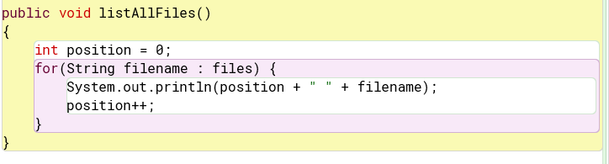

4.25: No if it does not exist, I got an error.

4.26:
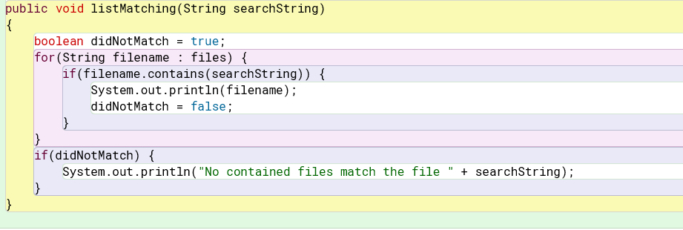

4.27:

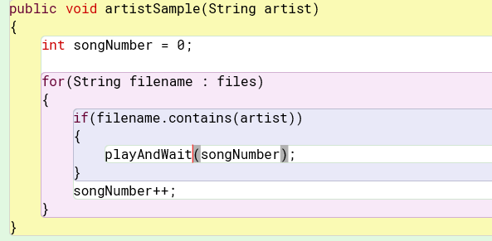

4.28: for(String tracks : Track)

4.29:
boolean found = false;
while(!found) {
if(the keys are in the next place) {
found = true;
}
}
4.30:
Public void multiplesOfFive()
{
Int minimum = 10;
While(minimum <= 95) {
System.out.println(minimum);
Minimum = minimum + 5;
}
}

int currentNum = 0;
int number = 1;

while(number <= 10) {
currentNum += number;
number++;
}
System.out.println(“Sum is equal to: “ + currentNum);

4.32:
public int sum(int a, int b)
{
Int sum = 0;
Int currentNum = 1;
While currentNum <= b) {
sum = sum + currentNum;
currentNum = currentNum + 1;
}
return sum;
}
4.33:
Public Boolean prime(int number)
{
Int minNumber = 2;
While (minNumber < number) {
If(number % minNumber == 0) {
Return false;
}
minNumber = minNumber + 1;
}
Return true;
}

4.38:
Added the stopPlaying() method when another track is called to begin.

4.39:
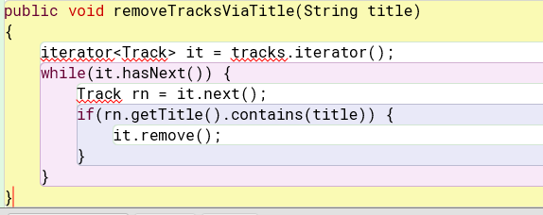

4.40:

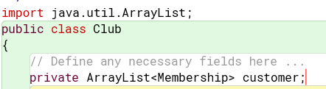

4.41:
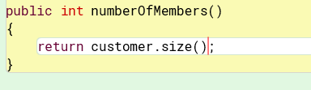

4.42:
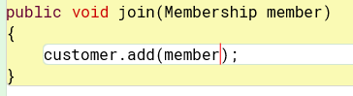

4.43:
public void playRandomSong() {
if(tracks.size() > 0) {
Random num = new Random();
int index = num.nextInt(tracks.size());
playTrack(index);
}
}

4.44: I would probabally make a loop that checks if the song has already been played and then remove it if it has been, I would then call the random method and play the song and remove it. Or assuming that there are no duplicates I would make a list and randomize and play it and after remove it.

4.45:
public void shuffle()
{
ArrayList<Track> notPlayed = new ArrayList<Track>(tracks);
Collections.shuffle(notPlayed);
for(Track : notPlayed)
{
Play.playSample();
}
}

4.47:
Boolean goodBid = selectedLot.bidFor(new Bid(bidder, value));

4.48:
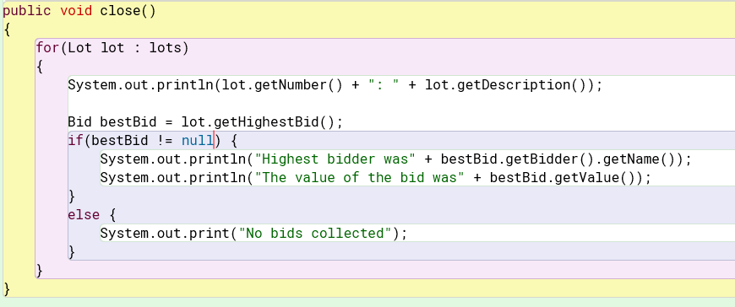

4.49:
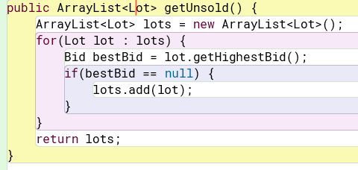

4.50: There would probabally be a error because the order would be changed and not match.

4.51:
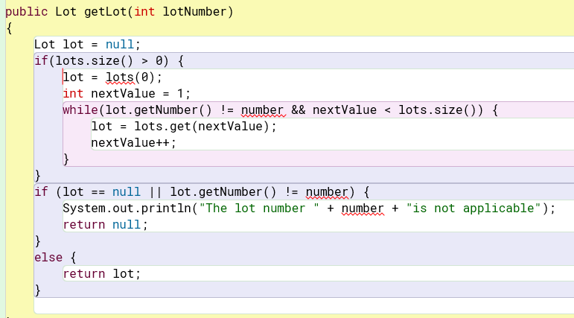

4.52:
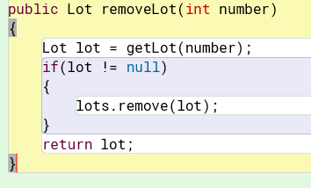

4.53:
It seems like the add methods and get methods are not in ArrayList while there are methods called void ensureCapacity, and voidtrimToSize that are not found in LinkedList.

4.54:
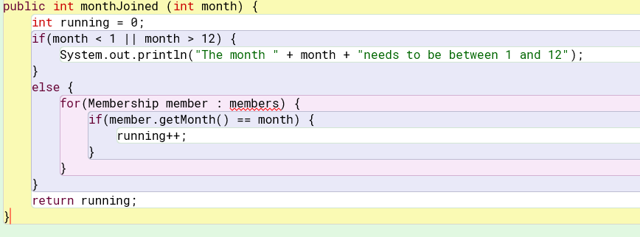

4.55:
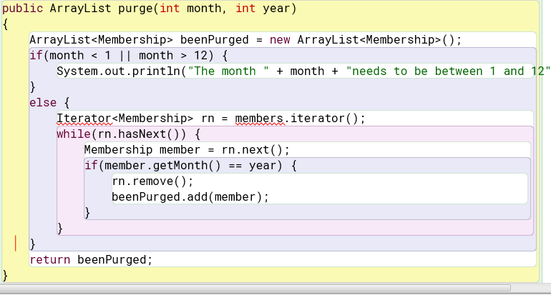

4.56:
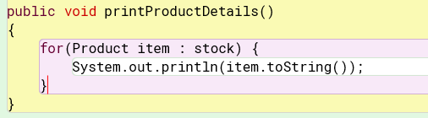

4.57:
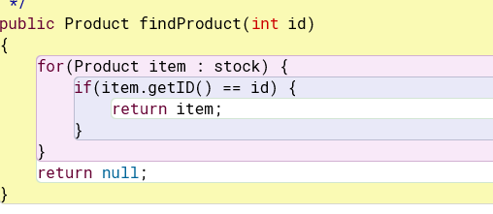
4.58:
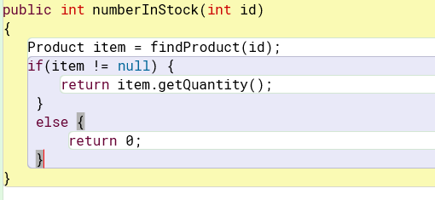

4.59:
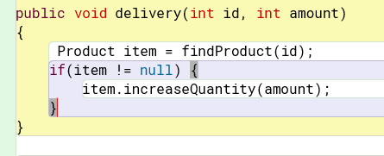

4.60: 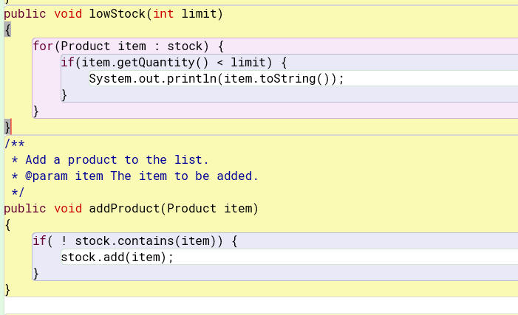

4.84: It seems to be a loop that repeats for each element in a list while a condition is true or false.

4.85:
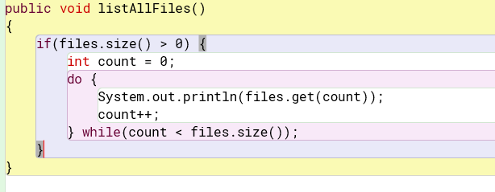

4.86:
